Java Programming – Boot Camp

Start Date – April 8, 2020

* Work on Java Programming Fundamentals
* Video Recording also being done and made available to students
* Interview Questions also being discussed in sessions
* Programs shown in online session are uploaded on moodle daily.
* 12 Assignments for Core Java uploaded on moodle.
* Apart from assignment other questions also uploaded on moodle.
* WhatsApp group also created – where daily some questions are floated and students participate in it.

What can be done to improve student participation?

* Weekly test on moodle with MCQ and Programming questions

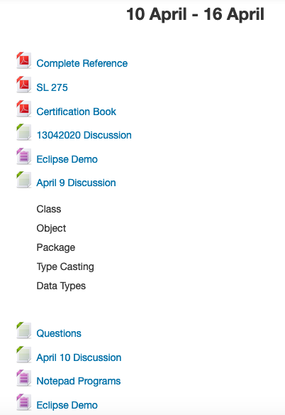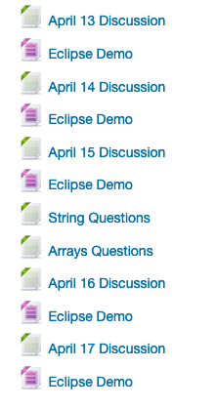c